# Migrating Virtual Machines to use Availability Zones

# Overview

Azure Availability Zones are one or more facilities in an Azure region that are physically and logically isolated from one another. This enables a greater isolation of resources while providing low latency and enables transparent placement and management of resources. Utilizing Availability Zones helps to protect you from datacenter-level failures. They are located inside an Azure region, and each one has its own independent power source, network, and cooling. To ensure resiliency, there's a minimum of three separate zones in all enabled regions.

Availability Zones are currently in preview. Please register your subscriptions by following the instructions at the following link:

# Scenarios

The following process and scripts support specific scenarios and should not be used as an “all inclusive” migration tool. The supported scenario requirements are as follows:

### Moving Availability Set Virtual Machines to Availability Zones

* Must convert the load balancer from Basic SKU to Standard SKU first using the supplied PowerShell Script (if not already using the Standard SKU)
* Load Balancer must contain only Availability Set Virtual Machines and not additional single Virtual Machines
* Virtual machine(s) must be using managed disk
* Must use supported Availability Zone VM sizes
* Understand the public IP will change

### Additional requirements applicable to all scripts

You must ensure you are running the latest Windows PowerShell version (5.1 and above) to support the script commands.

# How To

### Planning to Migrate Availability Sets

Migration of VM-based applications from Availability Sets to Availability Zones is a two-step process.

1. Convert the Software Load Balancer used by VMs in the Availability Set from the Basic SKU to the new Standard SKU which supports Availability Zones. If VMs are not load balanced by a load balancer, they are behind a 3rd party load balancer or the Azure load balancer is already a “Standard SKU” load balancer, this step may not be required.
2. Migrate VMs to specific Availability Zones in an Azure region by deleting the VM definition and recreating it in the new zone. This process is different depending on whether the VM is in an Azure load balancer (see step #1 above) or not.

**Caution**: As these scripts to delete and re-create resources to convert them from Basic to Standard SKUs (for load balancers) or from regional VMs to VMs in specific zones (for VMs), they are potentially destructive. If an issue with the script does not allow it to succeed fully, the resource (LB or VM) may not get re-created correctly. Please backup your resource definitions and test thoroughly before using.

### Converting the Azure Load Balancer to “Standard SKU”

*Note: This step will be required if you are using the basic SKU for your existing Azure load balancer. If your load balancer is already using the Standard SKU you may skip this section.*

*Note: If you are using a different load balancer type (such as F5, Azure Traffic Manager, etc.) then you need to run the* *Single Virtual Machine Migration* *process and address your load balancer accordingly.*

**Determine the load balancers, subid’s and resource group names you wish to migrate**

To perform the conversion process, you will first need to identify the following which will be used to perform the migration:

* *subid - The subscription ID for the Load Balancer you want to migrate*
* *lbname - Azure LB to move to Standard SKU / Regional Configuration*
* *lbresourcegroup - Resource group of Azure LB to move*

**Use the PowerShell Conversion Script to Convert the Software Load Balancer to a Standard SKU**

Use the provided Azure Load Balancer Migration script (AZLBMigrationToStandardSKU.ps1) for conversion of your load balancer. Run the provided script using the data captured on the PowerShell command line as below:

.\AZLBMigrationToStandardSKU.ps1 -subid **yoursubid** -lbname **yourlbname** -lbresourcegroup **yourresourcegroup**

Run the PowerShell Script for each of your load balancers you wish to convert.

**Verify the Conversion Completed Successfully**

You may verify the status of the conversion of the load balancer in the Azure Web Portal. The SKU should indicate Standard (which was converted from Basic)

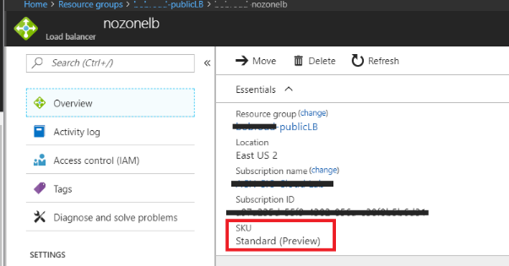

**Next Steps**

Once the load balancer has been converted, a second step is required to migrate the VM’s in the Azure load balancer backend pools into Azure Availability Zones.

## Migration of Azure Load Balanced VMs from Regional Availability Sets into Availability Zones

**Determine the load balancers, subid’s and resource group names you wish to migrate**

The script will migrate all VMs from the specified load balancer into Availability Zones in the same region where the VMs and load balancer currently exist.

To perform the migration process, you will first need to identify the following which will be used to perform the migration:

* *subid - The subscription ID for the VMs and Load Balancer to Migrate*
* *lbname - Azure LB containing the VMs to move to Availability Zones*
* *lbresourcegroup - Resource group of Azure LB containing the VMs to move to Availability Zones*

**Use the PowerShell Migration Script to Migrate your VM’s to Zones**

Use the provided Load Balanced VM Migration Availability Zone Migration script (MoveLBVMstoAZs.ps1). Run the provided script using the data captured on the PowerShell command line as below:

.\MoveLBVMstoAZs.ps1 -subid **yoursubid** -lbname **yourlbname** -lbresourcegroup **yourresourcegroup**

**Verify the Conversion Completed Successfully**

You may verify the status of the migration in the Azure Web Portal. The Provisioning State status for each should show “Succeeded”. A sample is below.

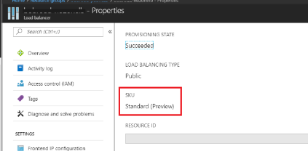

## 

# Planning Migration Timing

The process for converting Virtual Machines to use Availability Zones takes from 3-5 minutes per VM. Since the VMs become unavailable during this time a planned maintenance window is recommended to reduce time impact. The provided scripts migrate the Virtual Machines consecutively however; you may run multiple versions of the script if you choose to run concurrently. This would reduce the overall outage window for large numbers of Virtual Machines.

# Scripts

### Azure Load Balancer Migration script to convert to Standard SKU(AZLBMigrationToStandardSKU.ps1)

<https://github.com/RoudyBob/azmigrationscripts/blob/master/AZLBMigration-v7.ps1>

### Load Balanced Availability Set VM Migration To Availability Zones script (MoveLBVMstoAZs-.ps1)

<https://github.com/RoudyBob/azmigrationscripts/blob/master/MoveLBVMstoAZs-v7.ps1>

### 